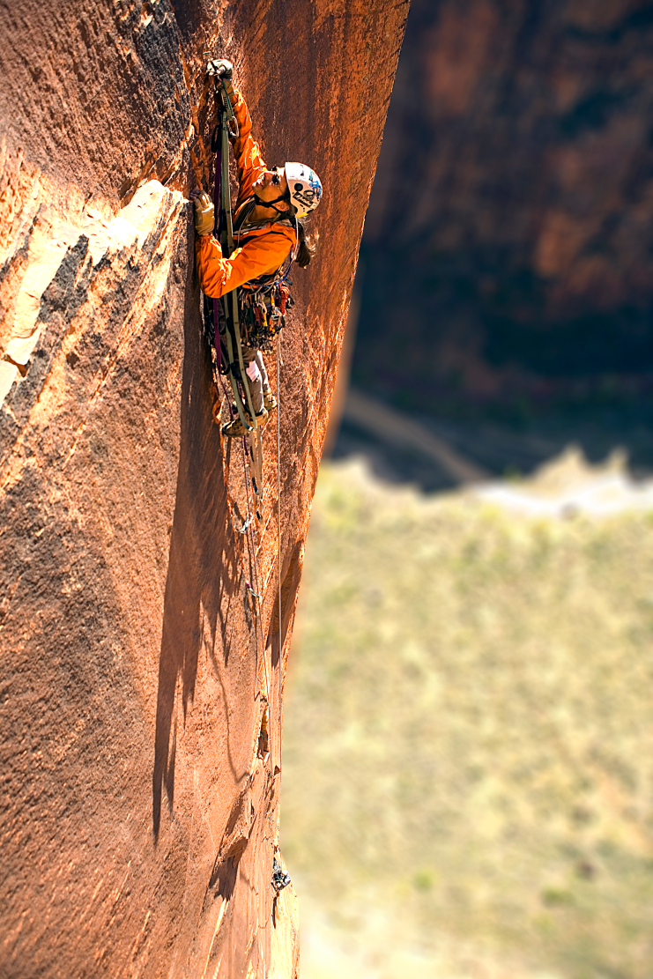

Manley Feinberg II
Vertical Lessons, Inc.
Human Voice: 314-724-3443
Manley@VerticalLessons.com
816 Aldan Drive
Saint Louis, MO 63132

VerticalLessons.com
Video Demo: ManleySpeaks.com
Twitter: @manleyf
LinkedIn: LinkedIn.com/in/manleyf/
Facebook: Facebook.com/manleyf

Manley Feinberg II Bio Options

About Manley (445 words)

Manley is recognized as an award winning international keynote speaker, business leader, and author whose work has been featured on NBC, CBS, ABC, and Fox, and in The New York Daily News, Entrepreneur, American Express Open Forum and World News. He served two terms as the President of the National Speakers Association, St. Louis chapter.

Leveraging more than twenty years of business, professional speaking and adventure experience, he helps professionals develop breakthrough mindsets to step up and reach their next summit. As a result of his work, people have more focus, courage, commitment and momentum.

In fact he wrote a book titled, Reaching Your Next Summit! 9 Vertical Lessons for Leading with More Impact.

During Manley’s eleven years with Build-A-Bear Workshop, his leadership direction helped take the revolutionary retail concept from 40 stores to over 400 worldwide, realizing revenue growth from 55 million to over 474 million, and a successful IPO on the NYSE. He built an award winning reputation for implementing business solutions and support that produced measurable results every day. Manley’s leadership influence contributed to a workplace culture that landed Build-A-Bear on the FORTUNE 100 Best Companies to Work For® List four years in a row.

It is this expertise that he shares by applying lessons learned in business and adventures to life’s daily challenges. The authentic, sincere and deep interpersonal connection Manley makes with your audience enables him to deliver practical and proven content to help organizations maximize their opportunities and develop their most valuable asset, their employees. Through custom developed programs and support ranging from 60 minutes to 12 months, he will leave you with many actionable techniques, frameworks, and insights. Most importantly, he can engage your organization in a way that drives real ROI that you can sustain well beyond the presentation, and ultimately affect long term change.

Manley’s inspirational keynotes are brought to life through his national geographic photography and riveting stories culminating from a lifetime of adventure through 25 countries, to over 400 outdoor destinations. Manley vividly shares compelling lessons from his adventure and leadership experiences in a way that allows you to relate to your mountains. He will have you hanging beside him surviving in the Himalayas, struggling to communicate in Uzbekistan, and immediately transfer the experience to moving you forward in your courageous efforts.

Manley will challenge your mindset, arm you with ideas you can use, and inspire you to action.
On a personal note, he likes to sleep on the side of mountains.
More shocking is that his wife has been putting up with that for more than two decades, and his two teens still kiss him on the cheek in front of their friends.

About Manley (260 words)

Manley is recognized as an award winning international keynote speaker, business leader, and author whose work has been featured on NBC, CBS, ABC, and Fox, and in The New York Daily News, Entrepreneur, American Express Open Forum and World News.

Through gripping keynotes and Vertical Experiences, Manley helps individuals and teams build breakthrough mindsets to step up and reach their next summit.

In fact, he wrote a book titled, Reaching Your Next Summit! 9 Vertical Lessons for Leading with More Impact.

During Manley’s eleven years with Build-A-Bear Workshop, his leadership direction helped take the revolutionary retail concept from 40 stores to over 400 worldwide, realizing revenue growth from 55 million to over 474 million, and a successful IPO on the NYSE. He built an award winning reputation for implementing business solutions and support that produced measurable results every day. Manley’s leadership influence contributed to a workplace culture that landed Build-A-Bear on the FORTUNE 100 Best Companies to Work For® List four years in a row.

Using stories from his personal experiences, Manley weaves together lessons he has learned from the vertical and business worlds and creates actionable lessons which help inspire others to step up and reach their next summit. As a result of his work, people have more focus, more commitment and more momentum.

On a personal note, he likes to sleep on the side of mountains.
More shocking is that his wife has been putting up with that for more than two decades, and his two teens still kiss him on the cheek in front of their friends.

About Manley (191 words)

Manley is the founder of Vertical Lessons, Inc. Manley is recognized as an award winning international keynote speaker, business leader, and author whose work has been featured on NBC, CBS, ABC, and Fox, and in The New York Daily News, Entrepreneur, American Express Open Forum and World News. Leveraging more than twenty years of business, professional speaking and adventure experience, his insight and energy will inspire and equip you to step up and reach your next summit.

In fact, he wrote a book titled, Reaching Your Next Summit! 9 Vertical Lessons for Leading with More Impact.

Manley’s 11 years of leadership influence contributed to a workplace culture that landed Build-A-Bear Workshop on the FORTUNE 100 Best Companies to Work For® List four years in a row. Manley served two terms as the president of the St. Louis chapter of the National Speakers Association

On a personal note, Manley likes to sleep on the side of mountains. Even more shocking is that his wife has been putting up with that for more than two decades, and he has two teens that still kiss him on the cheek in front of their friends.

About Manley Financial / Insurance Industry Bio (226 words)

Manley is recognized as an award winning international keynote speaker, business leader, and author whose work has been featured on NBC, CBS, ABC, and Fox, and in The New York Daily News, Entrepreneur, American Express Open Forum and World News. In 1995 he started Vertical Lessons.

Leveraging more than twenty years of business, professional speaking and adventure experience, he helps professionals’ breakthrough mindsets to step up and reach their next summit. As a result of his work, people have more focus, courage, commitment and momentum.

In fact, he wrote a book titled, Reaching Your Next Summit! 9 Vertical Lessons for Leaingd with More Impact.

Manley’s 11 years of leadership influence and mission critical project success contributed to a workplace culture that landed Build-A-Bear Workshop on the FORTUNE 100 Best Companies to Work For® List four years in a row.

In 2016, Manley received a standing ovation as the closing keynote speaker for MDRT’s elite Top of the Table event. He has worked with multiple organizations in the financial services and insurance industries throughout his career to help achieve sustained breakthrough performance.

On a personal note, he likes to sleep on the side of mountains.
More shocking is that his wife has been putting up with that for more than two decades, and his two teens still kiss him on the cheek in front of their friends.

